**Question 1:**

**Vissim Travel Time Simulation**

**Part 1**

Figure showing Link list

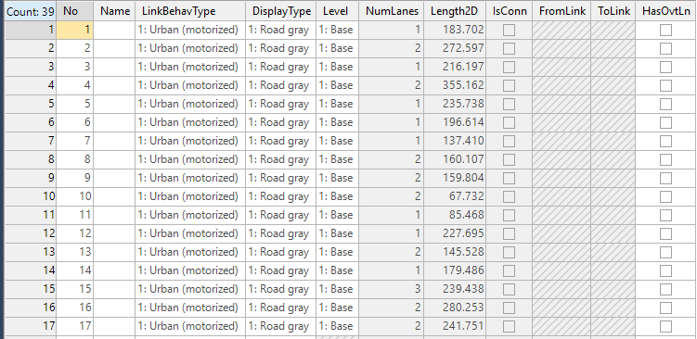

Figure showing Connector list

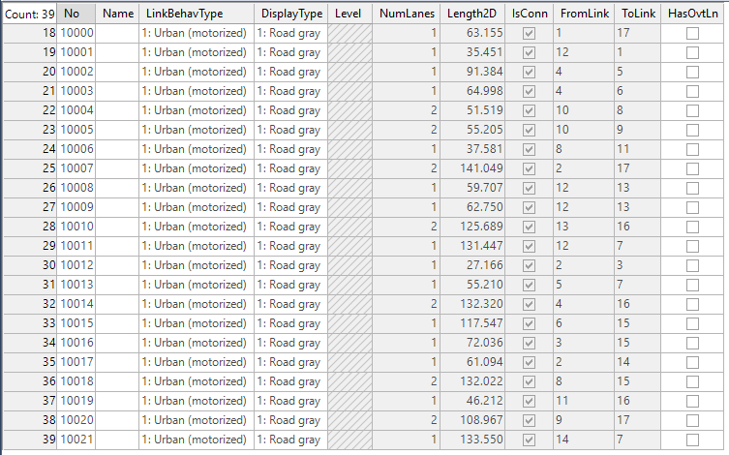

Figure Showing Vehicle Inputs

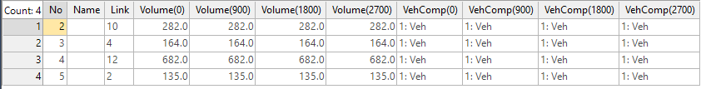

**Part 2:**

Vehicle travel time evaluation results are shown in the following figures after successful running of the simulation.

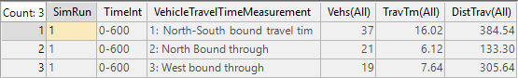

**Question 2:**

**Deriving Greenberg’s macroscopic model from GM-3 car-following model**

GM-3 car-following model:

${\ddot{x}}_{n+1}\left(t+∆t\right)=\frac{α_{0}}{x_{n}\left(t\right)-x_{n+1}\left(t\right)}\left[{\dot{x}}_{n}\left(t\right)-{\dot{x}}_{n+1}\left(t\right)\right]$

Integrating both sides of the equation we get,

${\dot{x}}_{n+1}=α_{0}ln\left(x_{n}\left(t\right)-x_{n+1}\left(t\right)\right)+C_{1}$

Now,

$x_{n}\left(t\right)-x_{n+1}\left(t\right)$ denotes the space between two vehicles, which we represent as $1/k$,

So, we re-write the equation as

$u=α_{0}ln\left(1/k\right)+C_{1}$

Let constant $C_{1}$ be substituted for $α_{0}lnC_{2}$, then

$u=α_{0}ln\left({C_{2}}/k\right)$

Now, when $k=k_{j}$, $u=0$ (at jam density flow is 0)

We get,

$0=α_{0}ln\left({C_{2}}/{k_{j}}\right)$

Solving we get,

$C_{2}=k_{j}$

Finally, the equation can be written as

$u=α_{0}ln\left({k_{j}}/k\right)$

This is the Greenberg’s macroscopic model logarithmic equation. (derived)

**Question 3:**

**Deriving Q=KV from Little’s law**

We know Little’s law is,

$\overline{L}\left(t\right)=\frac{A\left(t\right)}{t}×\overline{W}\left(t\right)$

To derive the relationship, we take $\overline{L}\left(t\right)$ as number of vehicles on the roads, and $\overline{W}\left(t\right)$ as average travel time.

Assuming the length of the road is $L$, we get

${\overline{L}\left(t\right)}/L={\left(\frac{A\left(t\right)}{t}×\overline{W}\left(t\right)\right)}/L$

By dividing both sides of the equation for Little’s Law by $L$

Now,

${\overline{ L}\left(t\right)}/L=K$,

where $K$ denotes the density.

Again,

$\frac{A\left(t\right)}{t}$ = Q , where Q denotes the arrival rate/flow of vehicles.

Again,

${\overline{W}\left(t\right)}/L=1/V$,

where $V$ means the average speed of all vehicles.

So, combining we obtain,

$K=Q/V$, or

$Q=KV$.